



# Online Voter System

**Development**

Following the Software Development Life Cycle (SDLC)

## -BY:

**Mohit Kumar Lovepreet Singh Nikhil Pradhan**

MK

**Introduction to SDLC**

### preencoded.pngDefinition



SDLC is a structured approach to software software development, providing a roadmap roadmap for creating high-quality software software products. It encompasses a series of series of well-defined phases, each with its its specific objectives and deliverables.

### Importance

Ensures systematic project execution by by breaking down complex projects into into manageable stages. This structured

structured approach helps in better planning, planning, resource allocation, and risk management throughout the development development lifecycle.

### Benefits

Improved efficiency, reduced costs, enhanced quality. SDLC leads to better resource utilization, minimizes rework, and and ensures that the final product meets the meets the desired quality standards and

and business objectives.

# Planning: Understanding the Goal



## Define Purpose

Objectives of the system system

## Identify Problem

Address voting challenges challenges

## Team Roles

Assign responsibilities







## Feasibility

Assess technical,

economic aspects

# Requirement Analysis

## Gather Info



Collect detailed information from stakeholders and users to to understand their needs and and expectations for the online online voting system.

Conduct surveys, interviews, and workshops to gather comprehensive requirements.

## Expectations

Define clear expectations for system features, including user registration, secure voting processes, and accurate results reporting.

Ensure the system complies with with all relevant legal and regulatory requirements for online voting.

## Document

Document all gathered requirements using collaborative collaborative tools such as Google Docs and GitHub for version control and easy access. access.

Create a comprehensive requirements specification document that serves as a blueprint for the development development team.

## Meetings

Conduct regular meetings with stakeholders to provide updates on the requirement analysis process and gather feedback.

Use these meetings to clarify any clarify any ambiguities and ensure that the development development team has a clear clear understanding of the project goals.

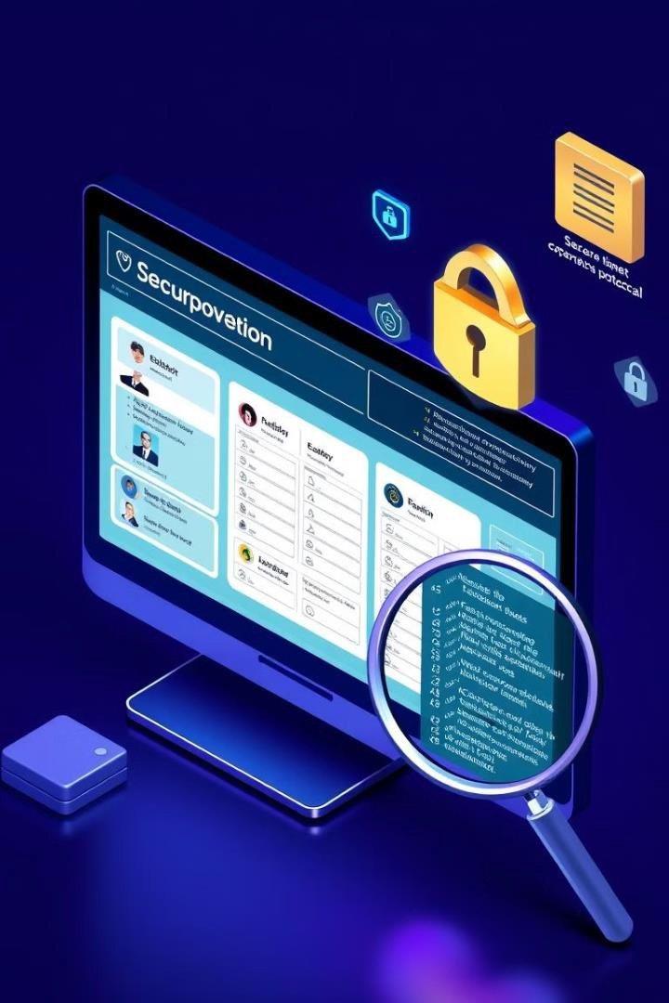

# Design: Creating a Blueprint

## Wireframe

Website layout sketch

## DB Structure

Voters, Candidates, Votes tables

## Technologies

HTML, CSS, JavaScript, Python



# Implementation: Coding the Project

* **Code**: Write clean, well-documented code following established coding standards. Use appropriate data structures and algorithms to ensure algorithms to ensure efficiency and scalability.
* **Version Control**: Utilize Git for version control, creating branches for new features or bug fixes. Regularly commit changes with clear and concise clear and concise commit messages.
* **Peer Review**: Conduct thorough code reviews to ensure code quality, identify potential bugs, and maintain consistency across the codebase.

# Testing: Ensuring Quality

## Integration Testing

Components together

**UAT**

End user feedback

## Unit Testing



Individual components

## Security Testing

Data protection



**2**

**3**

**1**

**4**



# Deployment: Launching the System

## Prepare



**1**

Server Setup



**Deploy**

**2**

Make system live

**Monitor**

**3**

Post-Deployment





**Maintenance: Long-term Success**

#### Regular Updates and Bug Fixes

**1**

**2**

**3**

Address any issues reported by users or identified through system monitoring. Implement Implement security patches to protect against vulnerabilities. Enhance system performance performance based on usage analysis.

#### Continuous User Feedback Integration

Collect user feedback through surveys and support channels. Prioritize feature requests and requests and improvements based on user input. Conduct usability testing to ensure a ensure a smooth user experience.

#### Comprehensive Documentation and Change Records

Maintain detailed documentation of all system updates and changes. Track issues,

issues, resolutions, and user feedback for future reference. Update user manuals and training and training materials to reflect system enhancements.



**Conclusion**

**SDLC Summary**

Successfully navigated SDLC,

delivering a robust and secure online online voter system through careful careful planning, design, and

maintenance.

**Future Work**

Enhancements: blockchain security,

multilingual support, and a mobile app for accessibility.

**Scalability**

Designed for scalability, handling growing voters and elections via cloud

cloud infrastructure, optimized database, high availability and performance. performance.